**CSS ASSIGNMENT**

**1. What are the benefits of using CSS?**

Ans:-

CSS is used for styling give to the HTML elements

Ex:-

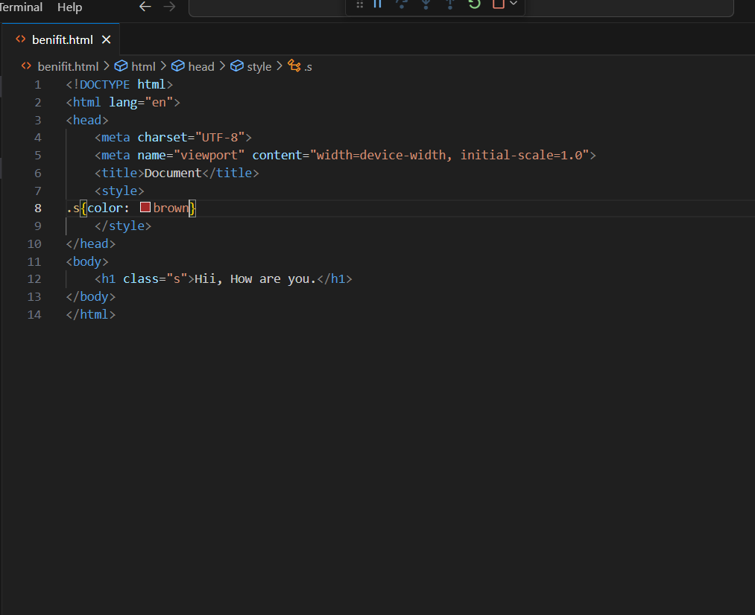

Output:-

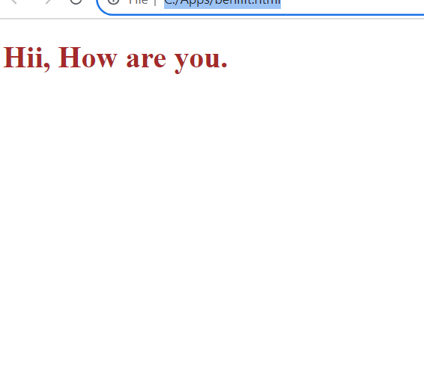

**2. What are the disadvantages of CSS?**

Ans:-

* Using multiple css files can take long time to load the web page.
* Css is work with one browser might not always work with another.
* The similar change affects on all browser.

**3. What is the difference between CSS2 and CSS3?**

Ans:-

* The breakdown code in modules in css3 but not in css2.
* css2 only web safe fonts can be used
* special font use css3 but not use in css2
* New ways for writing in css2 but not in css3
* Creating responsive design is not possible in css2 but possible in css3.
* css3 the selector were called as a sequence of simple selectors.com

**4. Name a few CSS style components**

Ans:-

The CSS style components are Attributes, Value of Properties, Margin, Padding etc.

Ex:-

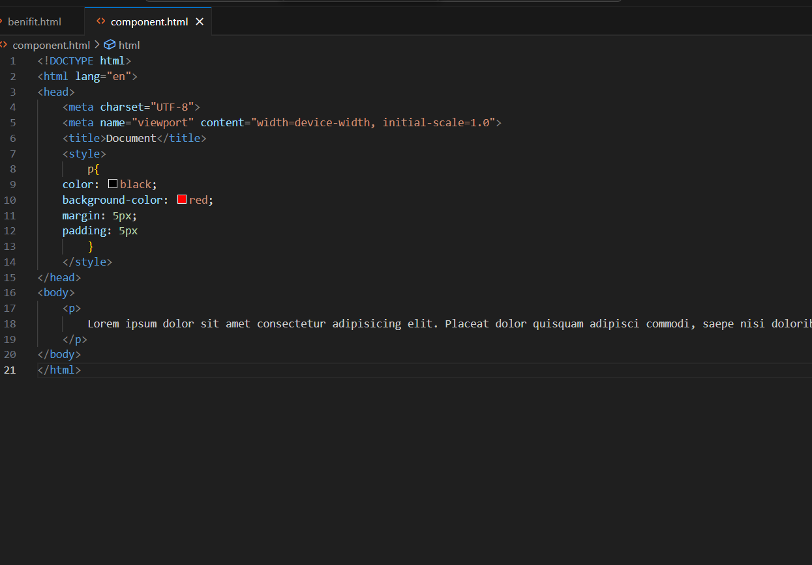

Output:-

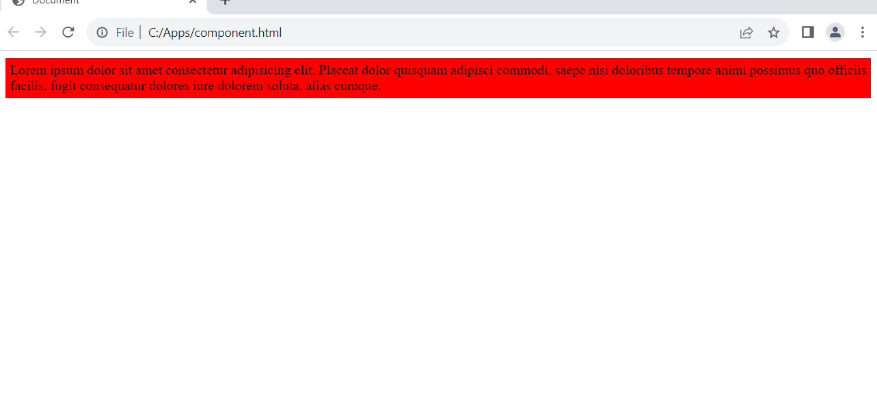

**5. what do you understand by css opacity**

Ans:-

The opacity is used for the transparency of an element. Or opacity is the degree to which content behind an element is hidden.

Ex:-

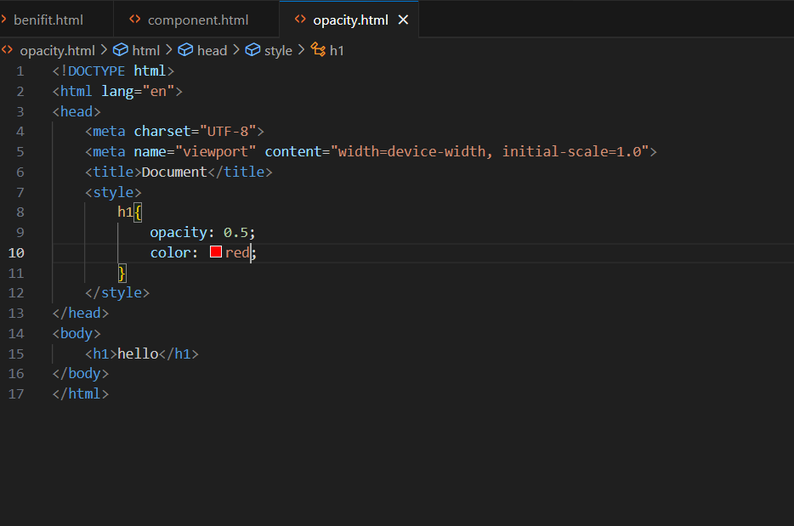

Output:-

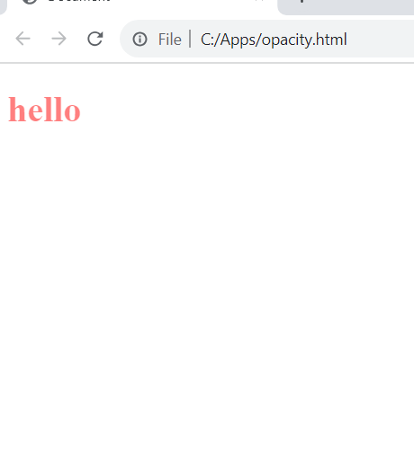

**6. How can the background color of an element be changed**

Ans:-

Change the background color in element by use the background-color property

Ex:-

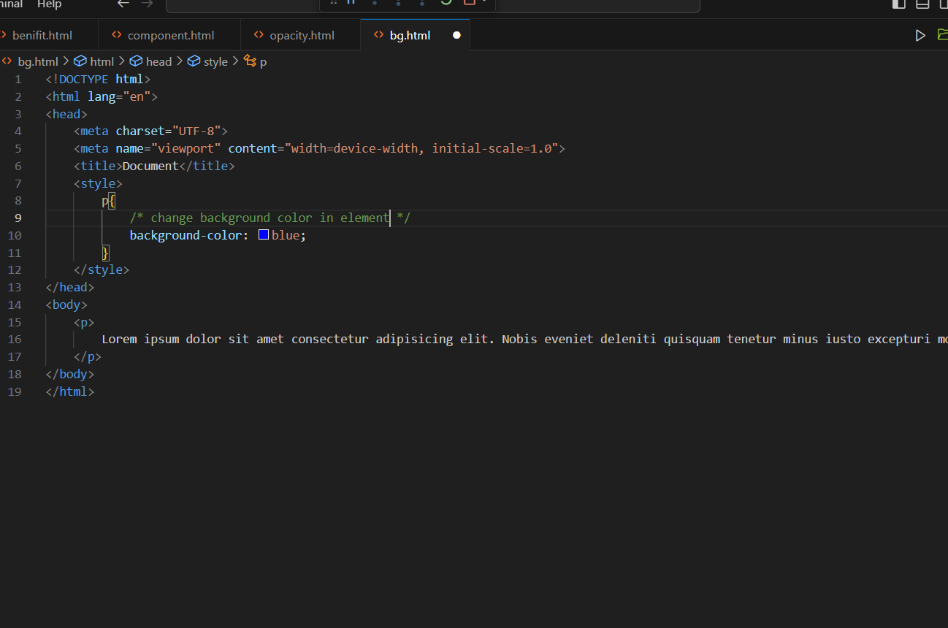

Output:-

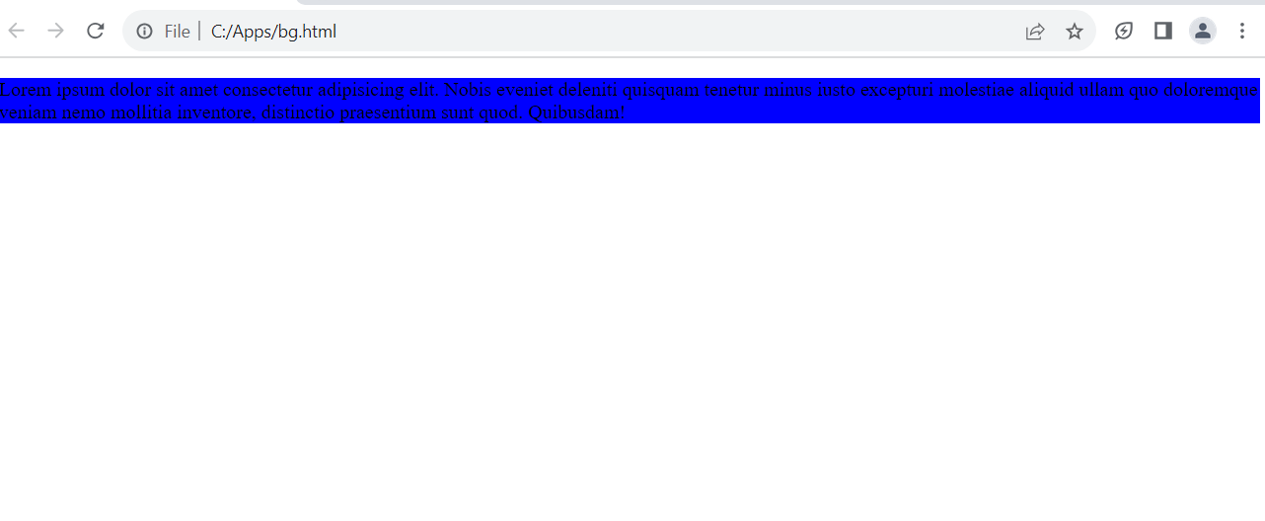

**7. How can image repetition of the backup be controlled?**

Ans:-

Stop image repetition of the background image with css property background-repeat: no-repeat;

Ex:-

**1.Repeat:-**

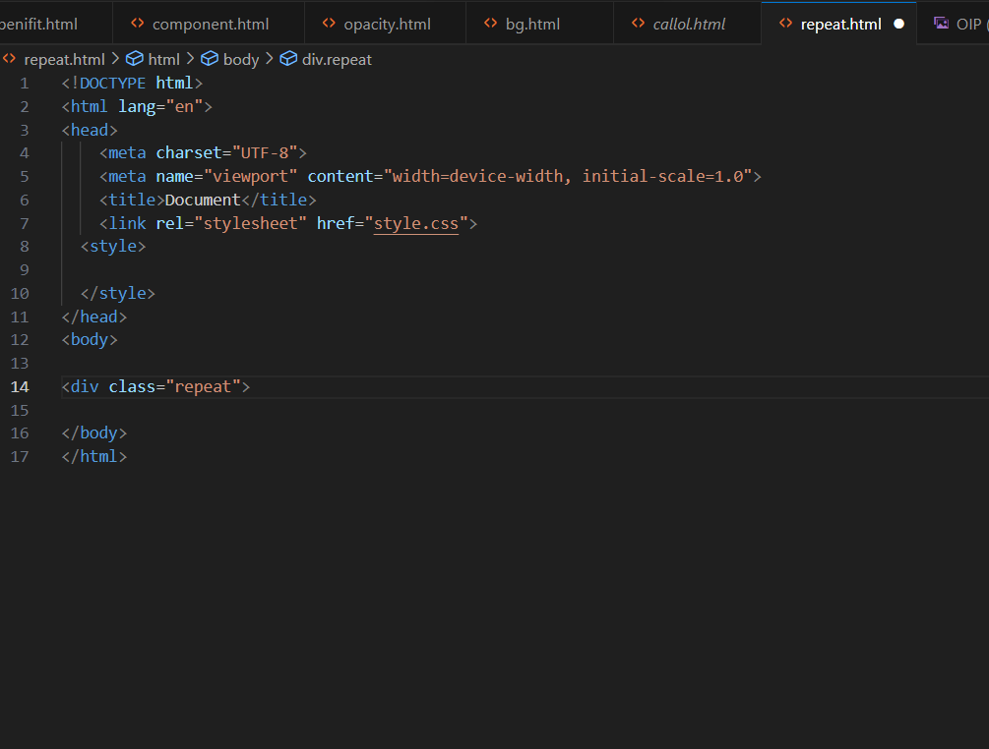

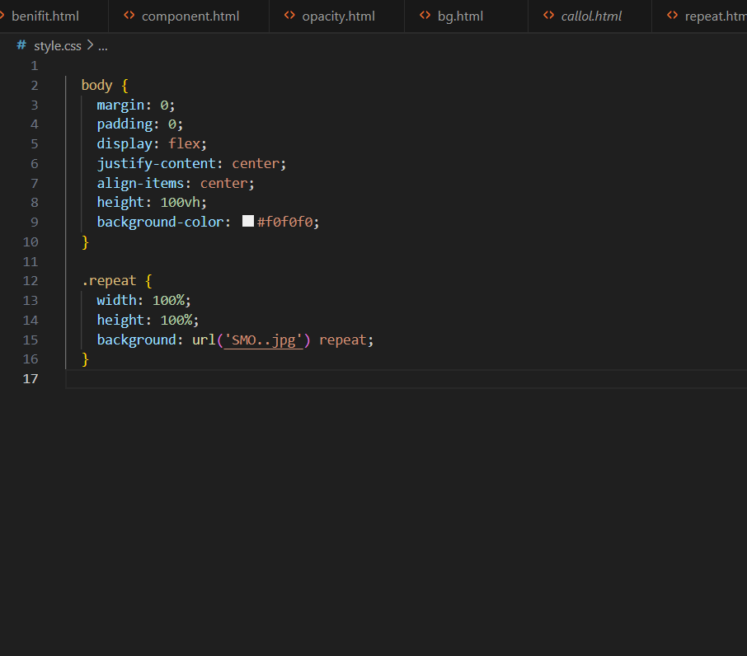

Output:-

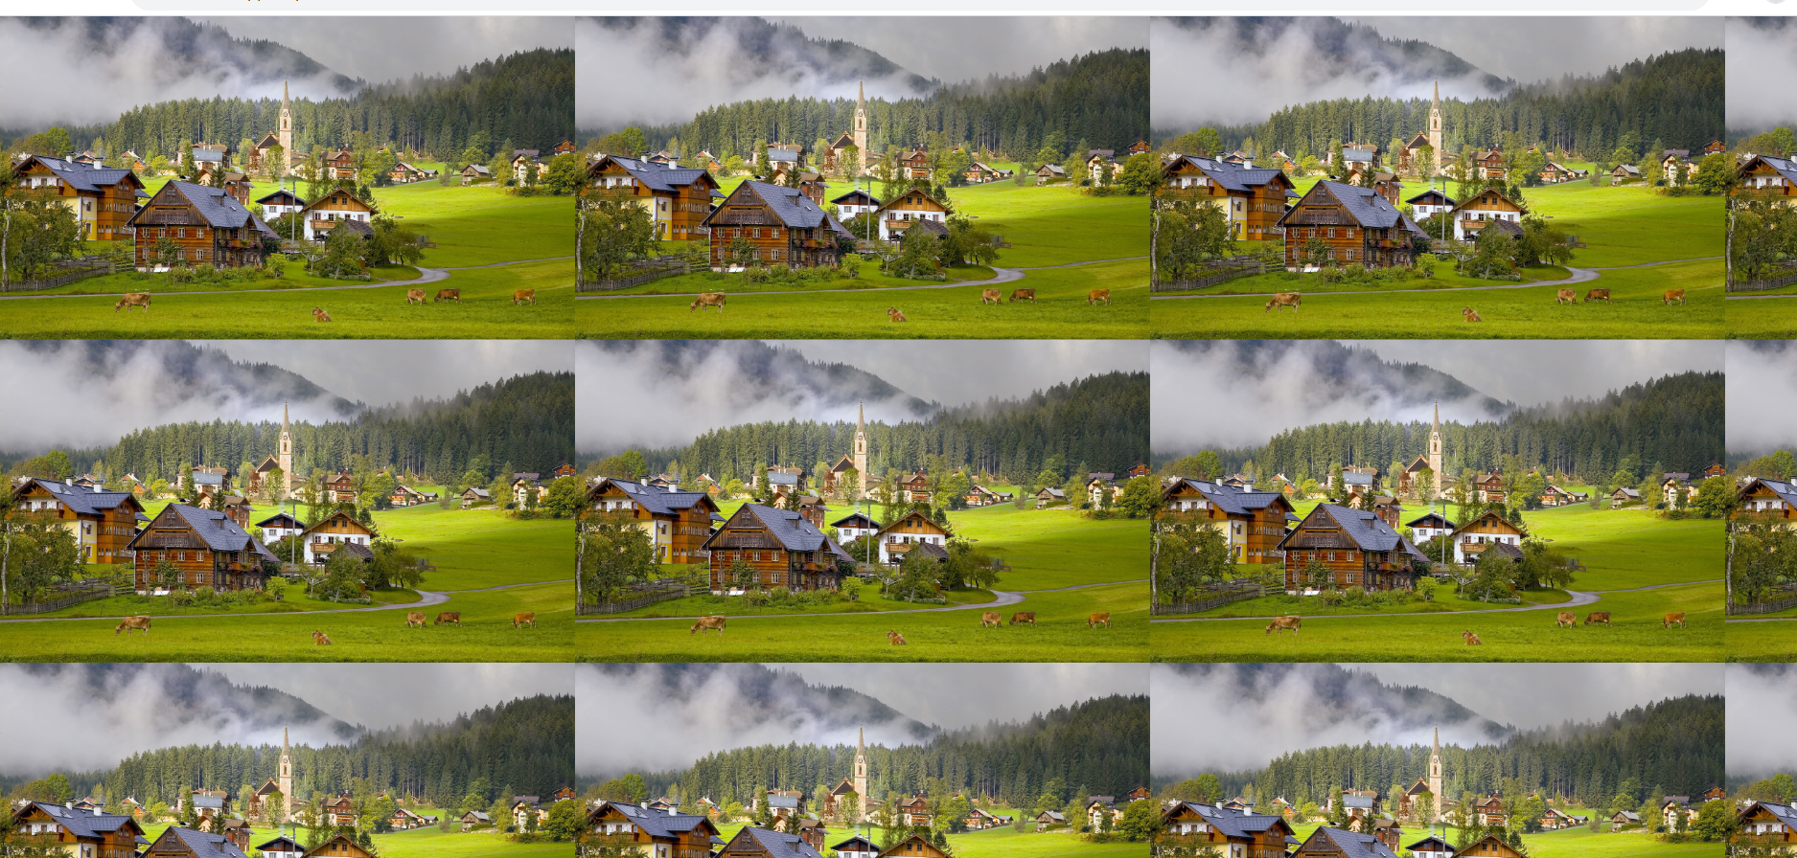

**2.No repeat**

Ex:-

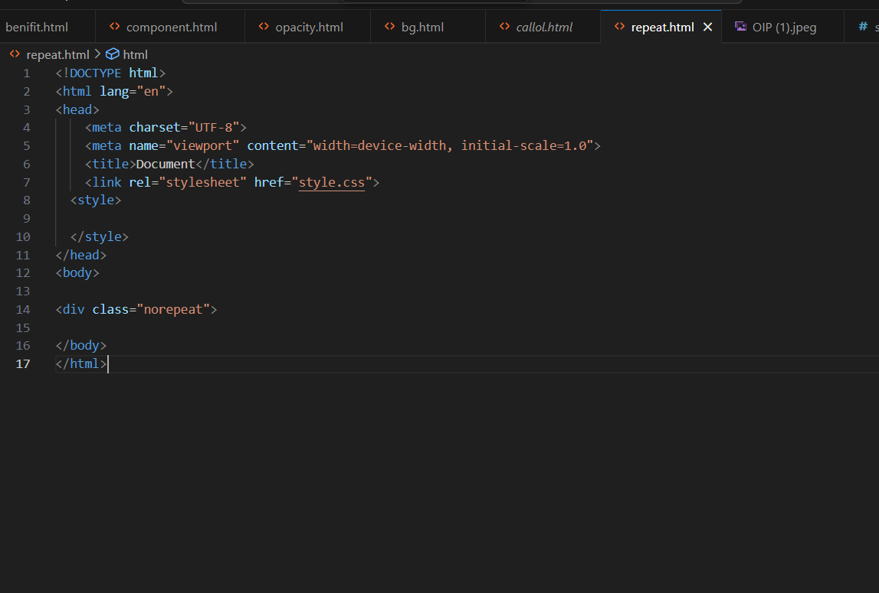

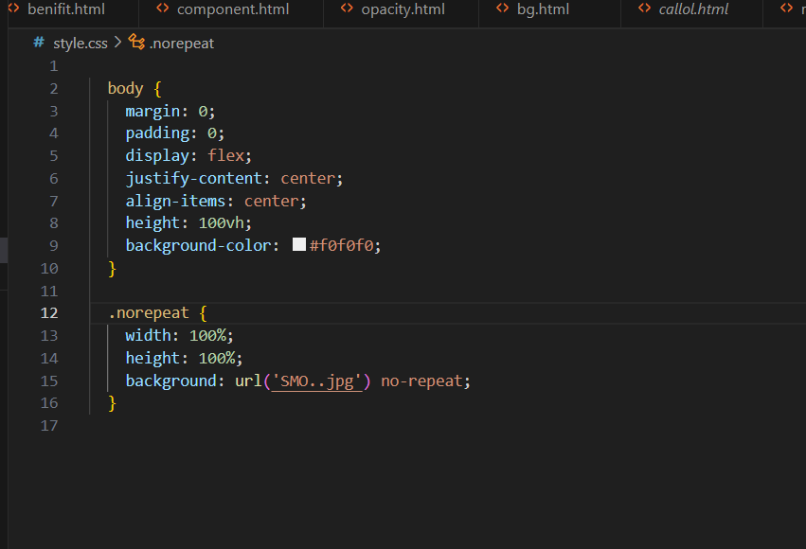

Output:-

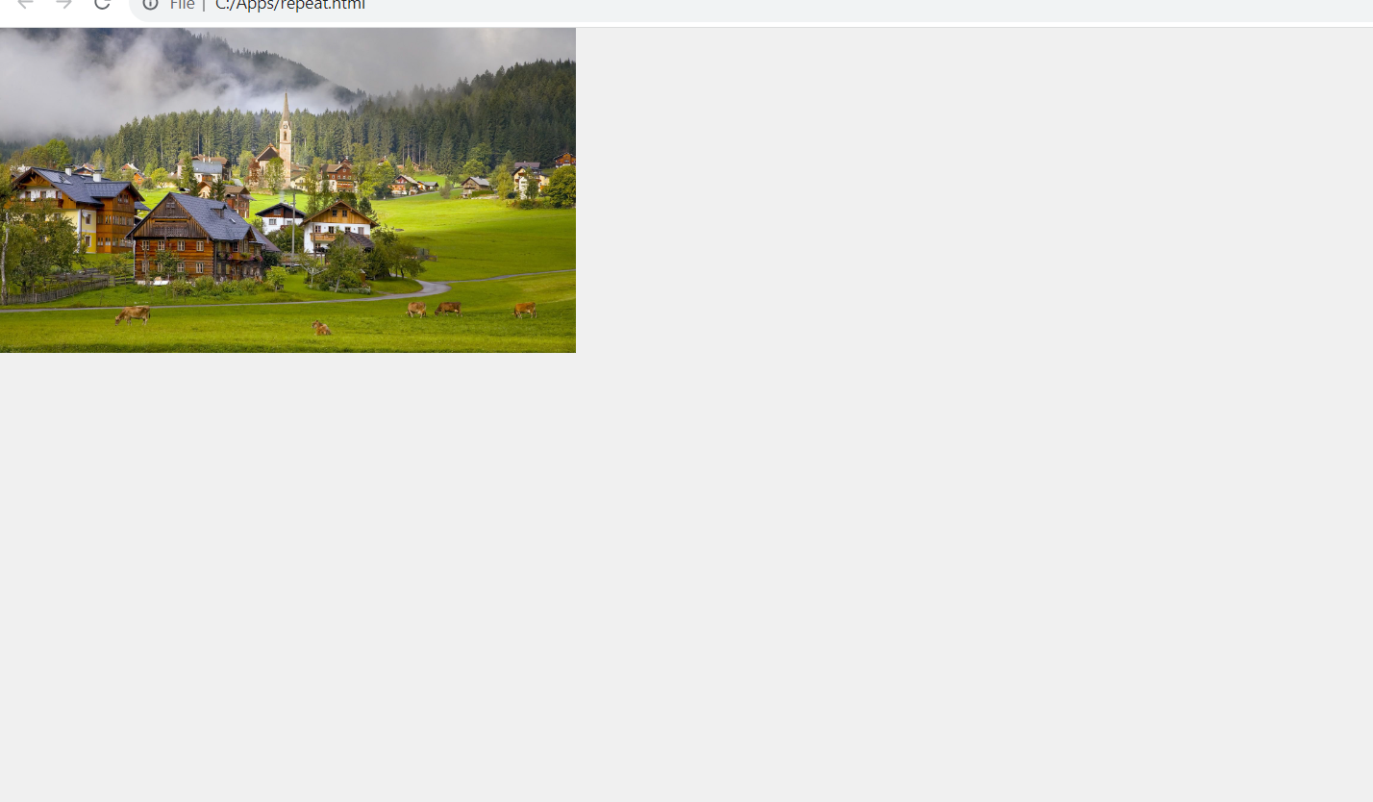

**8. What is the use of the background-position property?**

Ans:-

* The background-position property is used to move the background image around within its container.
* background-position property is used to put the position in the 4 directions top, left, right, bottom.

Ex:-

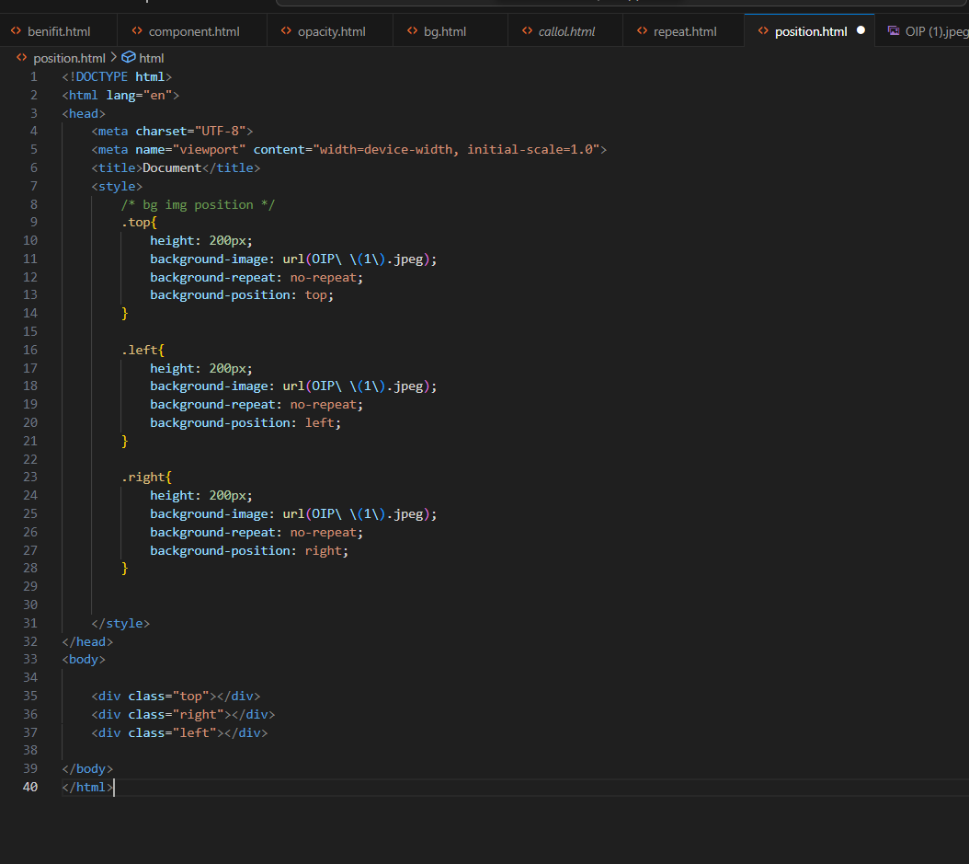

Output:-

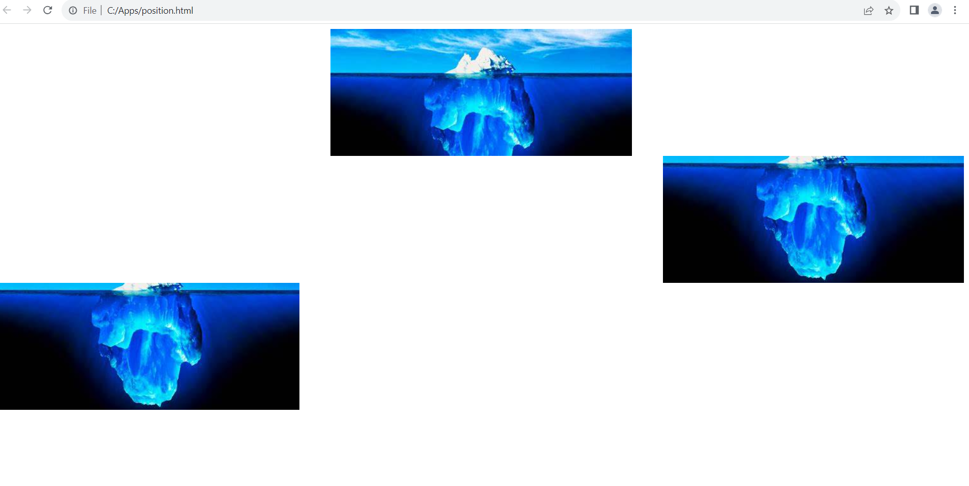

**9. Which property controls the image scroll in the background?**

Ans:-

The css property overflow: auto; control is the image scroll in the background.

Ex:-

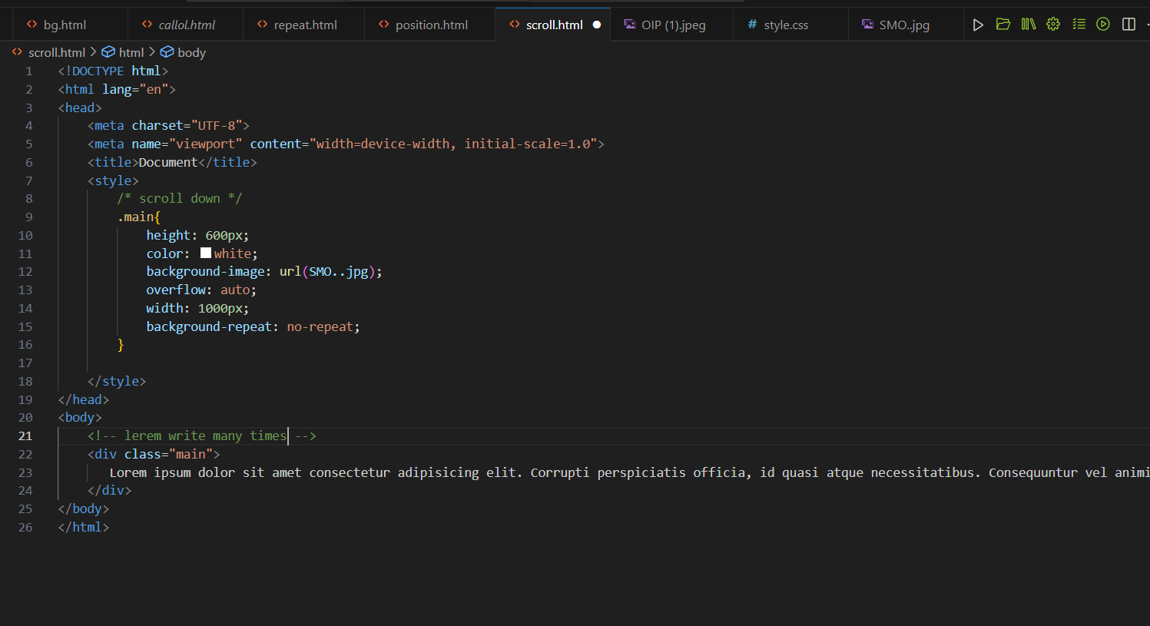

Output:-

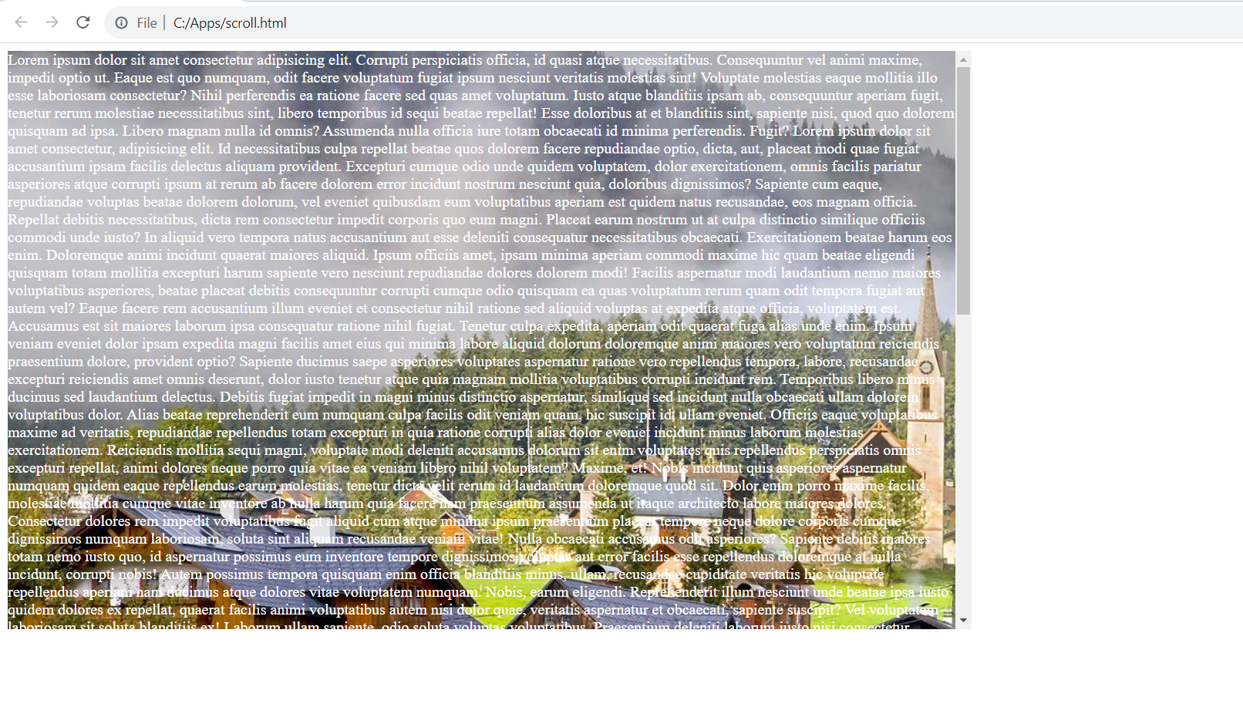

**10. Why should background and color be used as separate properties?**

Ans:-

* The background-color property to change the color of the background, while color property is only used to change the color of the font.

Ex:-

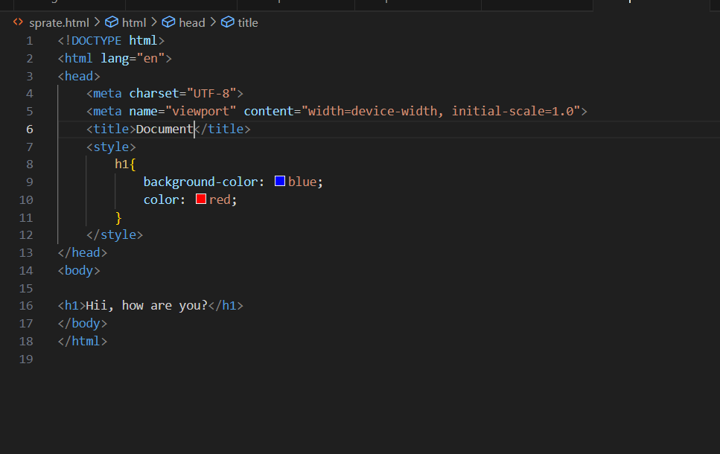

Output:-

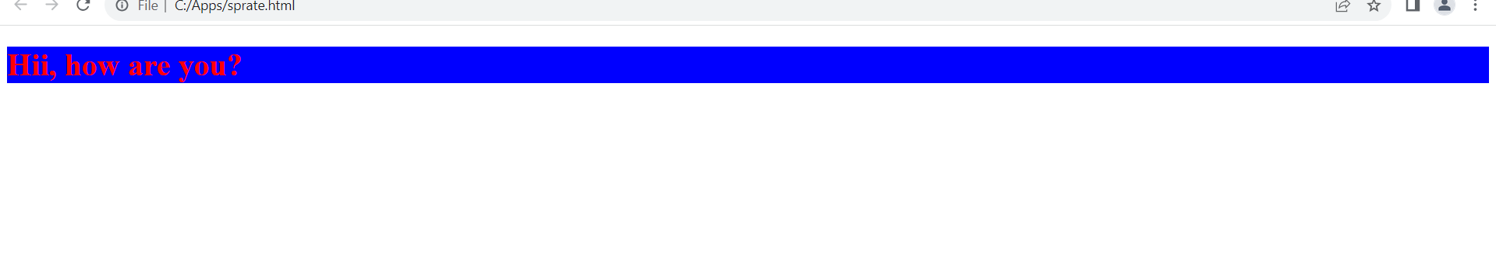

**11. How to center block elements using CSS1?**

Ans:-

* **Center the div using following CSS code.**

Ex:-

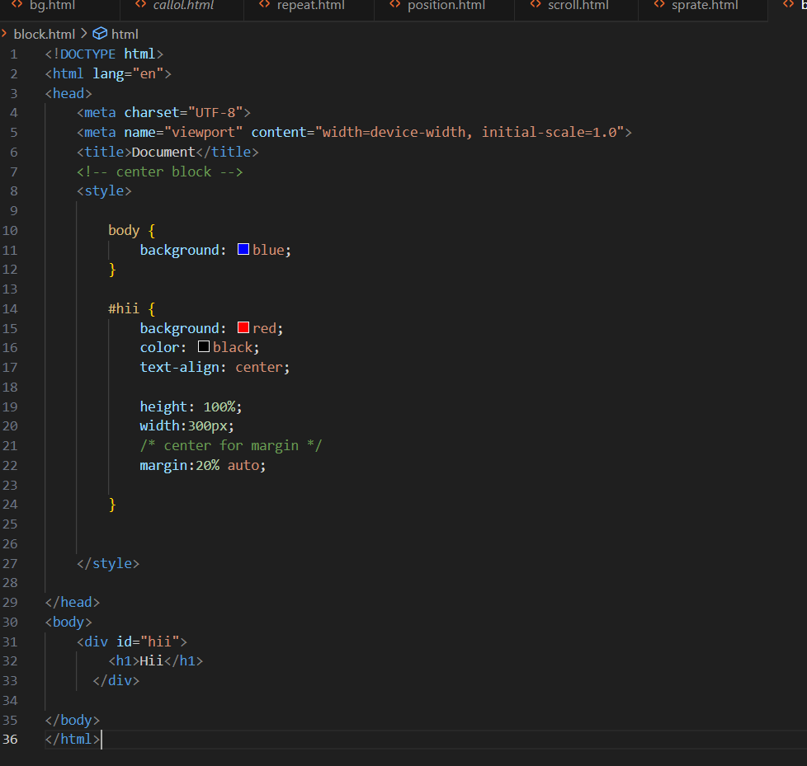

Output:-



**12. How to maintain the CSS specifications?**

Ans:-

* The css specifications Stay updated, Follow best practices, use css preprocessor, version control, modularize css, testing and validation, code reviews and stay engaged.
* The css code is larger than 400 lines then the html could should use external css file.

**13. what are the ways to integrate css as a web page?**

Ans:-

* There are three ways to integrate css in the web page.

1. Inline css:-

<h1 style=”color:red”>Hello, World!</h1>

1. Internal CSS:-

<style>h1{color: red};</style>

1. External CSS :-

<link rel="stylesheet" href="style.css">

**14. What is embedded style sheets?**

Ans:-

* Embedded style sheets means css code inside the style tag in the same html document.

Ex:- 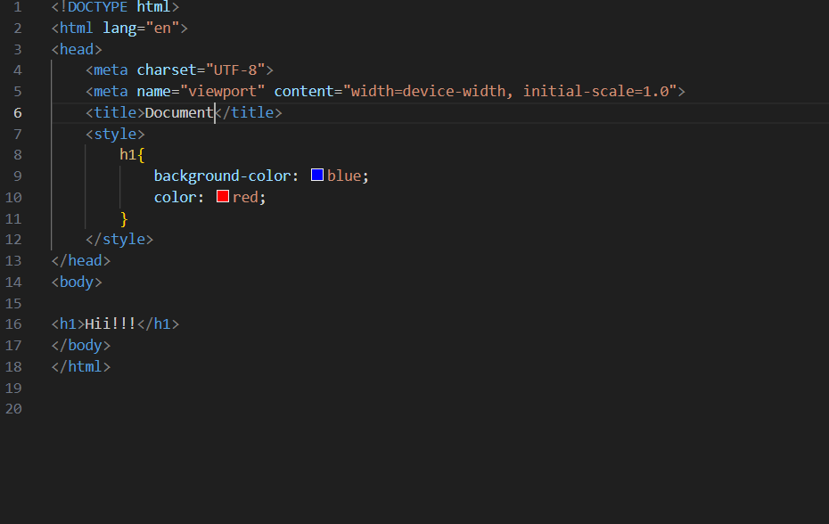

Output:-

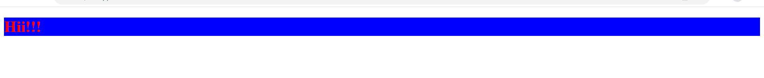

**15. What are the external style sheets?**

Ans:-

* External style sheets means to load css from different files.

Ex:-

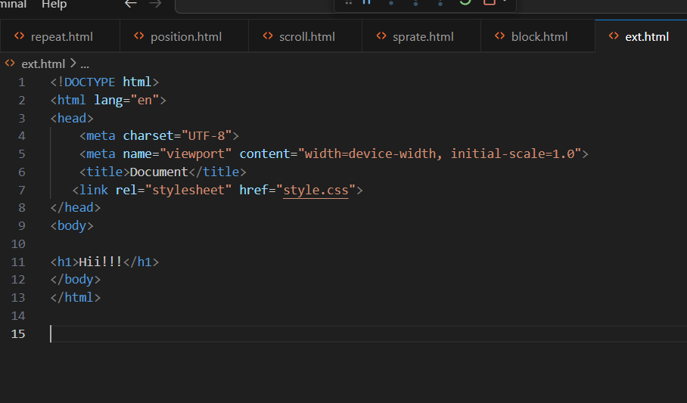

Output:-

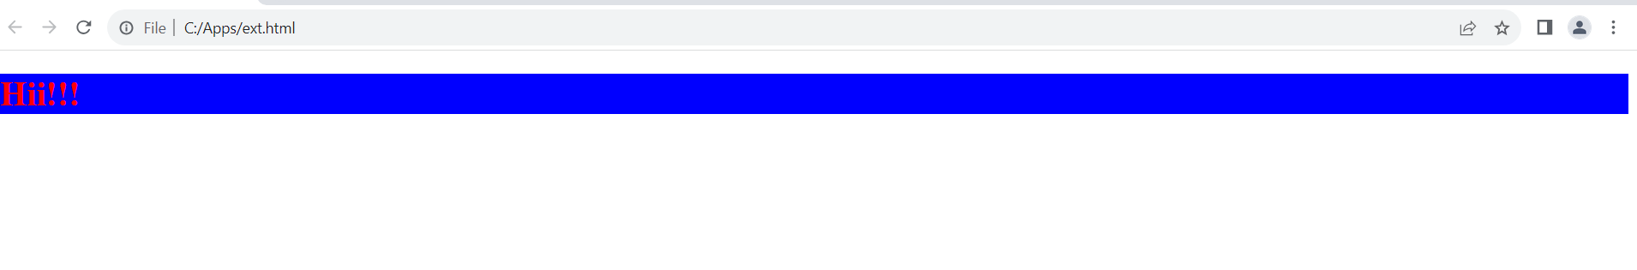

**16. What are the advantages and disadvantages of using external style sheets?**

Ans.

* Advantage :-

1. It makes the code cleaner.
2. Easy to read
3. Make changes on multiple file.

* Disadvantage:-

The page may not be rendered correctly until the external css is loaded.

Uploading or linking to multiple css file can increase your site’s download time.

**17. What is the meaning of the CSS selector?**

Ans:-

The css seclector is used to find or select the html elements you want to style.

It is a pattern of elements and other terms that tell the browser which HTML elements should be selected to have the CSS property values inside the rule applied to them.

Ex:-

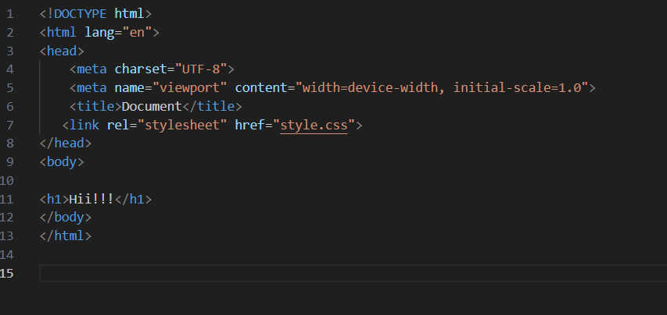

Output:-



**18. What are the media types allowed by CSS?**

Ans. The media type allowed by css is all, screen, print, speech, handheld, tv, braille, embossed, projection, tty, and aural.

All type of medias are allowed such as mp3, mp4, png, jpeg, gif, etc…

Ex:-

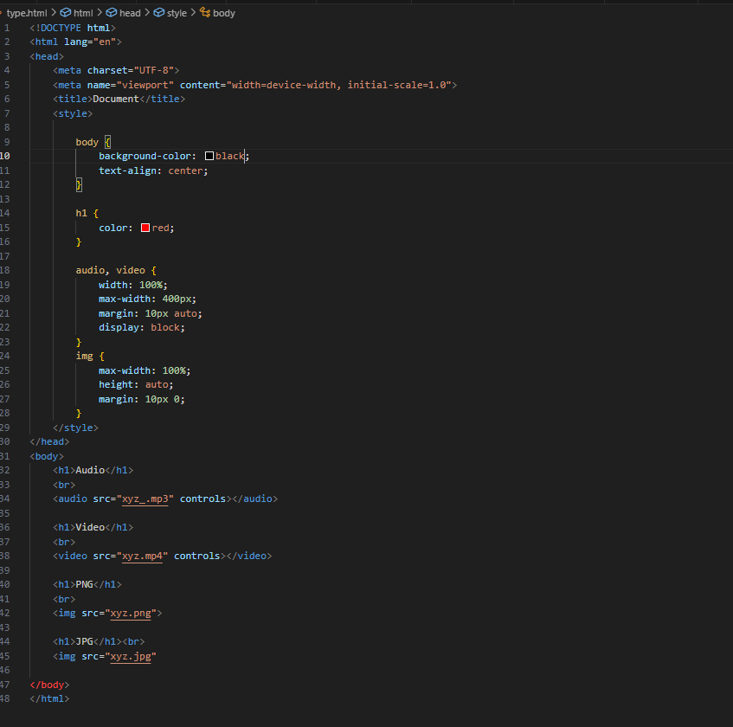

Output:-

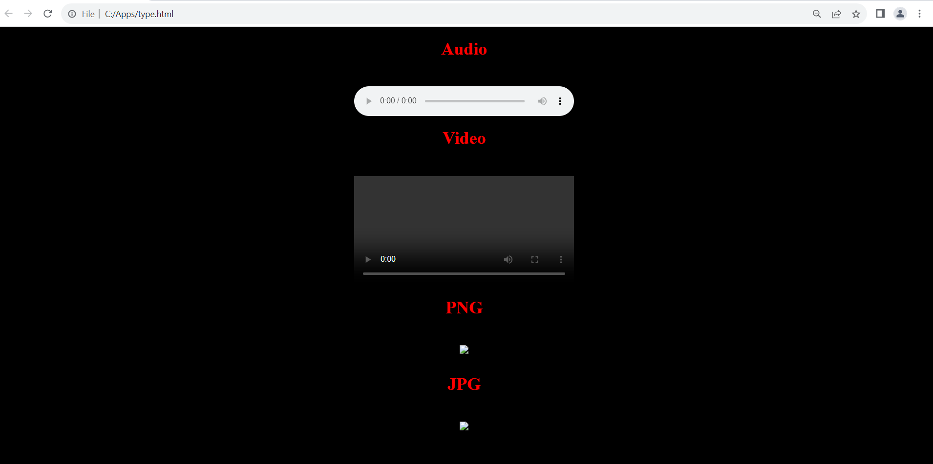

**19. What is the rule set?**

Ans:-

CSS rule set is contains one or more selectors and one or more declarations.

Ex:-

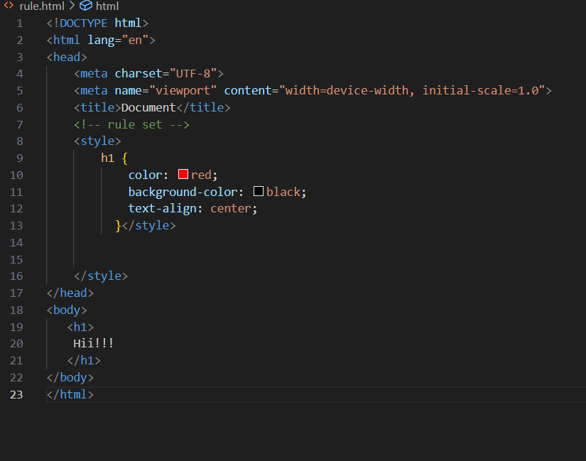

Output:-

